**Patch : partial update . Put : replaces completely even single field**

**Microservices Tracing:**

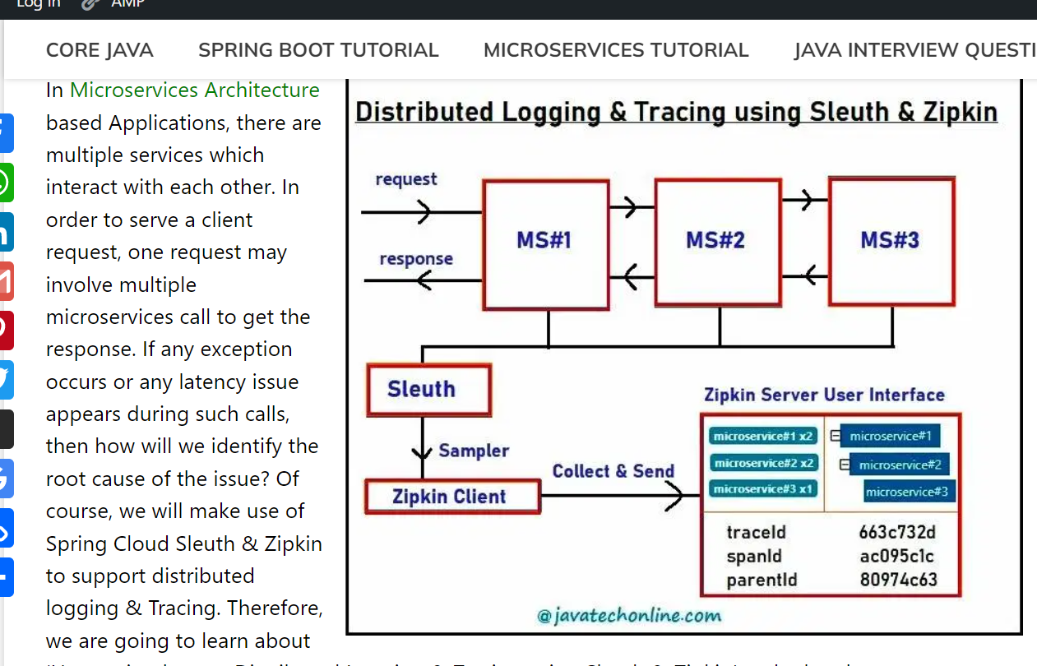

When should you use the builder pattern?

The builder pattern, as the name implies, is an alternative way to construct complex objects. This pattern should be used **when we want to build different immutable objects using the same object building process**

 focuses on constructing a complex object step by step. It also enforces a process to create an object as a finished product. That means an object must be massaged by some instructed steps before it is ready and can be used by others.

Java coding questions:

<https://www.indiabix.com/java-programming>

# What is Java Parallel Streams?

Java Parallel Streams is a feature of Java 8 and higher, meant for utilizing multiple cores of the processor. Normally any java code has one stream of processing, where it is executed sequentially. Whereas by using parallel streams, we can divide the code into multiple streams that are executed in parallel on separate cores and the result is the combination of the individual outcomes. The order of execution, however, is not under our control.

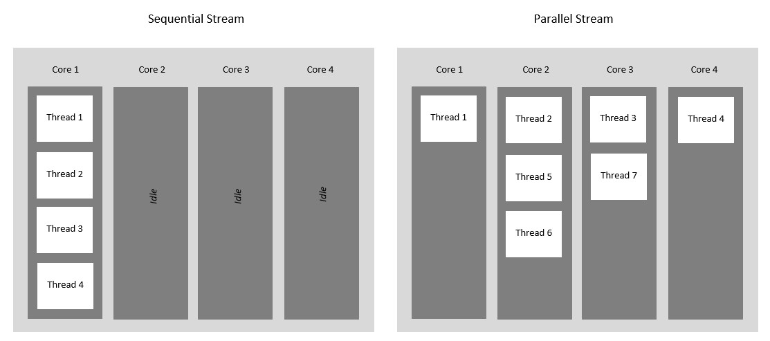

**spring-boot-jwt-authentication:**

<https://www.bezkoder.com/spring-boot-jwt-authentication/>

https://github.com/Java-Techie-jt/spring-security-jwt-example

Authentication and Authorization by using JWT:

#### **Spring Boot Rest Authentication with JWT (JSON Web Token) Token Flow**

[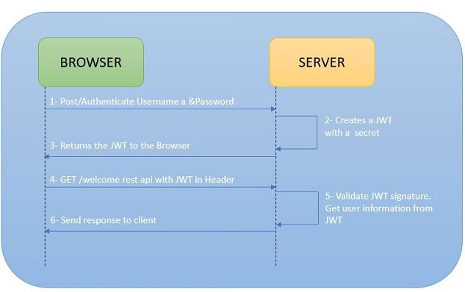](https://www.techgeeknext.com/jwt/spring-boot-jwt-workflow.JPG)

* Customers sign in by submitting their credentials to the provider.
* Upon successful authentication, it generates JWT containing user details and privileges for accessing the services and sets the JWT expiry date in payload.
* The server signs and encrypts the JWT if necessary and sends it to the client as a response with credentials to the initial request.
* Based on the expiration set by the server, the customer/client stores the JWT for a restricted or infinite amount of time.
* The client sends this JWT token in the header for all subsequent requests.
* The client authenticates the user with this token. So we don't need the client to send the user name and password to the server during each authentication process, but only once the server sends the client a JWT.

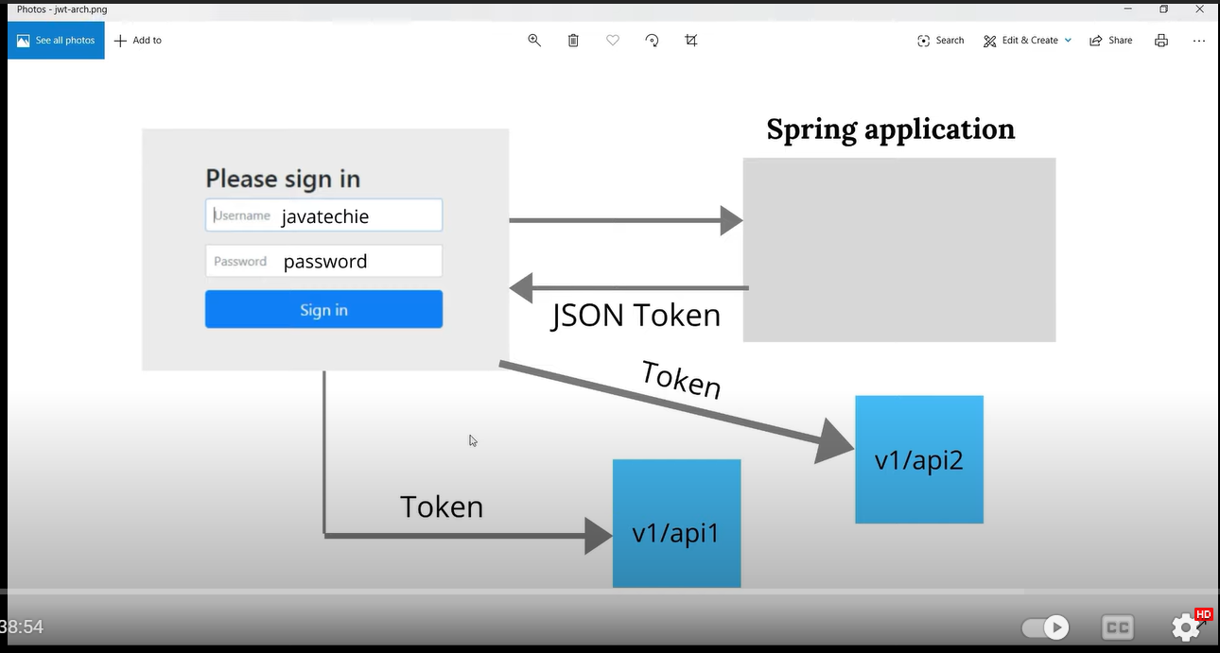

#### **What is database transaction?**

*A database transaction is a sequence of actions that are treated as a single unit of work. Transaction management is an essential aspect of RDBMS application to ensure data integrity and consistency. The transaction can be defined with ACID properties.*

1. **Atomicity** - All success or none.
2. **Consistency** - Integrity constraints must be maintained in such a way that the database is consistent before and after the transaction.
3. **Isolation** - One transaction should not impact on another transaction.
4. **Durability** - After completion of the transaction, the changes and modifications to the database will be stored in and written to the disk and will continue even if a system failure occurs.

How to add a filter in Spring Boot

Filters as the name suggest used to perform filtering on either the request to a resource or on the response from a resource, or both. *Spring Boot* provides few options to ***register custom filters*** in the *Spring Boot application*.With the help of filter, we can perform the following operations.

1. Perform some request processing before the request is handed over to the controller.
2. Processing response before it reaches the client.

Here is a sample code outlining a simple Servlet filter

@Component

publicclassMyFilterimplementsFilter {

@Override

publicvoiddestroy() {}

@Override

publicvoiddoFilter

(ServletRequest request, ServletResponse response, FilterChain filterchain)

throws IOException, ServletException {

*//place to perform request processing.*

}

@Override

publicvoidinit(FilterConfig filterconfig) throws ServletException {}

}

How to restrict data returned from database in hibernate?

**@JsonIgnore**

@Entity

public class Task {

@Id

@GeneratedValue(strategy = GenerationType.IDENTITY)

**@JsonIgnore**

private Integer Id;

@JsonProperty("task")

private String taskName;

private String status;

//getter and setter

}

After missing mandatory field(@not null) in json input(response body) sent from user. What exception you get? Exception thrown before the controller or in controller?

JsonParsing Exeception. Before controller.

# [**How to access Private Field and Method Using Reflection in Java?**](https://javarevisited.blogspot.com/2012/05/how-to-access-private-field-and-method.html)

<https://javarevisited.blogspot.com/2012/05/how-to-access-private-field-and-method.html#axzz7Nxh2dIYI>

# [Why Enum Singleton are better in Java? Examples](https://javarevisited.blogspot.com/2012/07/why-enum-singleton-are-better-in-java.html)

<https://javarevisited.blogspot.com/2012/07/why-enum-singleton-are-better-in-java.html#axzz7Nxh2dIYI>

# [10 Singleton Pattern Interview Questions in Java - Answered](https://javarevisited.blogspot.com/2011/03/10-interview-questions-on-singleton.html)

<https://javarevisited.blogspot.com/2011/03/10-interview-questions-on-singleton.html#axzz7Nxh2dIYI>

**What is Enum in java?**

Enum constants are [implicitly static and final](http://javarevisited.blogspot.sg/2011/12/final-variable-method-class-java.html) and you can not change their value once created. Enum in Java provides type-safety and can be used inside switch statements like int variables.

<https://javarevisited.blogspot.com/2011/08/enum-in-java-example-tutorial.html#axzz7Nxh2dIYI>

**Threads Methods:**

| Methods | Action Performed |
| --- | --- |
| isDaemon() | It checks whether the current thread is daemon or not |
| start() | It starts the execution of the thread |
| run() | It does the executable operations statements in the body of this method over a thread |
| sleep() | It is a static method that puts the thread to sleep for a certain time been passed as an argument to it |
| wait() | It sets the thread back in waiting state. |
| notify() | It gives out a notification to one thread that is in waiting state |
| notifyAll() | It gives out a notification to all the thread in the waiting state |
| setDaemon() | It set the current thread as Daemon thread |
| stop() | It is used to stop the execution of the thread |
| resume() | It is used to resume the suspended thread. |

## List down Important Annotations?

The most commonly used and important [spring boot annotations](https://howtodoinjava.com/spring-boot2/spring-boot-annotations/) are as below:

* @ComponentScan – enables component scanning in application classpath.
* @EnableAutoConfiguration – enables auto-configuration mechanism that attempts to guess and configure beans that you are likely to need.
* @Configuration – indicates that a class declares one or more @Bean methods to generate bean definitions and service requests for those beans at runtime.
* @SpringBootApplication – is a composite annotation composed on above 3 annotations. This enables auto-configuration mechanism, enable component scanning and register extra beans in the context.
* @ImportAutoConfiguration – imports and apply only the specified auto-configuration classes. We should use this when we don’t want to enable the default autoconfiguration.
* @AutoConfigureBefore, @AutoConfigureAfter, @AutoConfigureOrder – shall be used if the configuration needs to be applied in a specific order (before of after).
* @Conditional – annotations such as @ConditionalOnBean, @ConditionalOnWebApplication or @ConditionalOnClass allow to register a bean only when the condition meets.

**Microservices**:

<https://www.fullstack.cafe/interview-questions/microservices>

**cyclicbarrier**

<https://javarevisited.blogspot.com/2012/07/cyclicbarrier-example-java-5-concurrency-tutorial.html#axzz7OFqHFWZL>

**Introduction to Docker:**  
Docker is a very popular and powerful open-source containerization platform that is used for building, deploying, and running applications. Docker allows you to decouple the application/software from the underlying infrastructure.  
  
**What is a Container?**  
A container is a standard unit of software bundled with dependencies so that applications can be deployed fast and reliably b/w different computing platforms.

* Docker can be visualized as a big ship (docker) carrying huge boxes of products (containers).
* Docker container doesn’t require the installation of a separate operating system. Docker just relies or makes use of the kernel’s resources and its functionality to allocate them for the CPU and memory it relies on the kernel’s functionality and uses resource isolation for CPU and memory, and separate namespaces to isolate the application’s view of the OS (operating system).

### . What is Jenkins?

Jenkins is a self-contained, open-source automation server that can be used to automate all sorts of tasks related to building, testing, and delivering or deploying software. Jenkins can be installed through native system packages, Docker, or even run standalone by any machine with a Java Runtime Environment (JRE) installed.

### 2. Tell me something about Continuous Integration, Continuous Delivery, and Continuous Deployment?

**Continuous Integration:** A software development process where the changes made to software are integrated into the main code as and when a patch is ready so that the software will be always ready to be - built, tested, deployed, monitored - continuously.

**Continuous Delivery:** This is a Software Development Process where the continuously integrated (CI) changes will be tested & deployed continuously into a specific environment, generally through a manual release process, after all the quality checks are successful

**Continuous Deployment:** A Software Development practice where the continuously integrated (CI) changes are deployed automatically into the target environment after all the quality checks are successful

Based on the level of automation, the above three paradigms can be better represented as below -

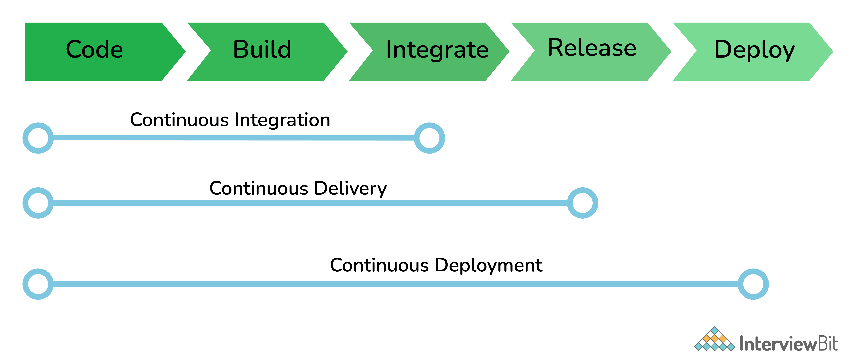

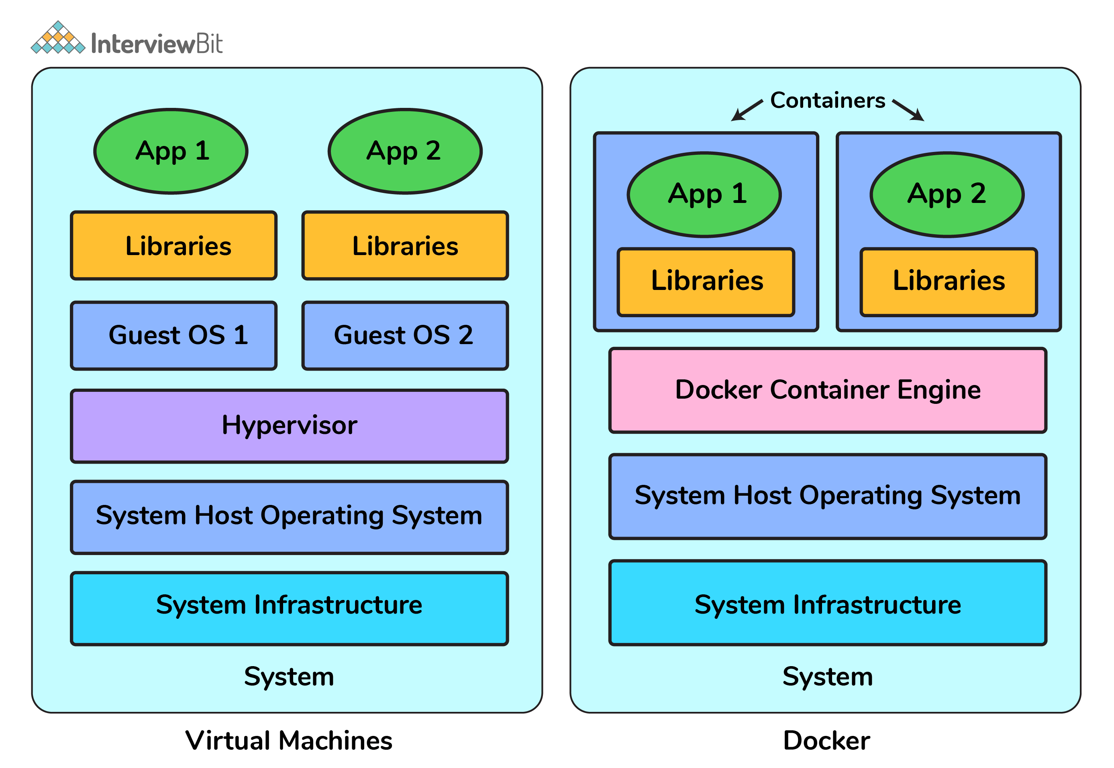

# **Differences between @RequestParam and @PathVariable in Spring MVC**

dineshonjava.com/requestparam-vs-pathvariable-annotations-in-spring-mvc/#:~:text=The%20key%20difference%20between%20%40RequestParam,values%20from%20the%20URI%20template.

@RequestMapping(value = "/tutorials/bookmark")

public String bookmark(

@RequestParam(value="site", required=true) String site,

@RequestParam(value="id", required=false) String id){

...

}

* **defaultValue**– It is String type attribute and the default value to use as a fallback when the request parameter is not provided or has an empty value.
* **name**– It is String type attribute and name of the request parameter to bind to.
* **required**– It is Boolean type attribute whether the parameter is required.
* **value**– It is String type attribute and it is alias for name attribute.

# Why wait(), notify() And notifyAll() methods are in Object Class?

<https://www.novixys.com/blog/java-reading-large-file-efficiently/>

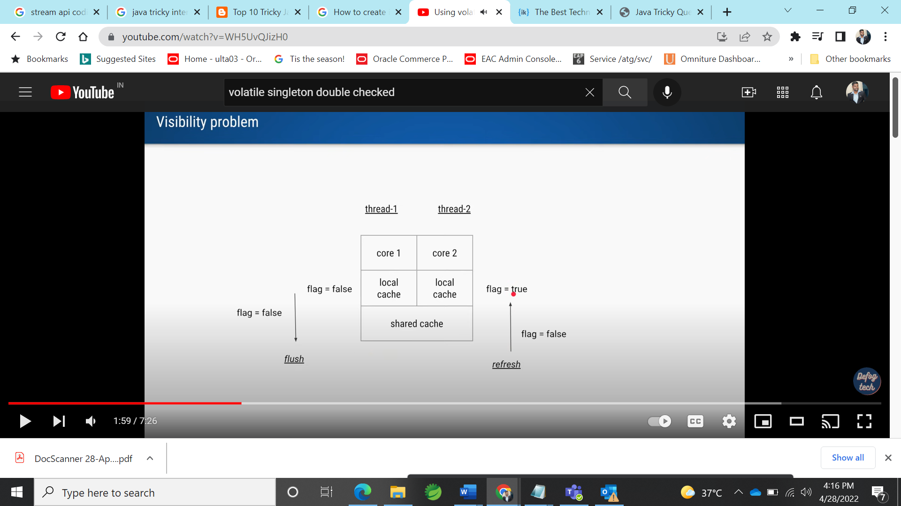

JVM memory management:

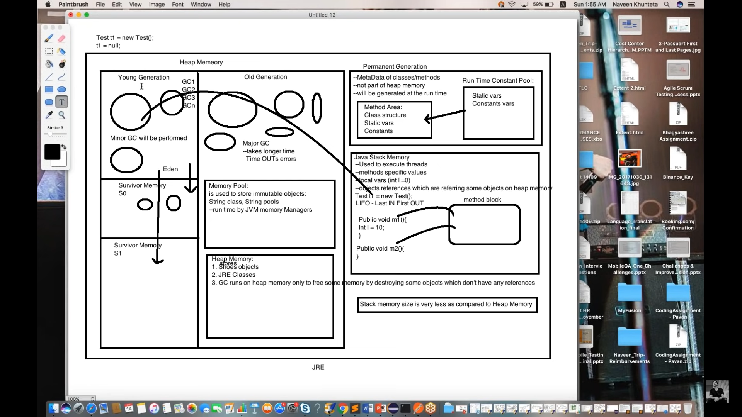

## Why String is Final in Java?

### 1. String Pool

### 2. Security

String has been widely used as a parameter for many Java classes like for opening network connection, you can pass hostname and port number as a string, you can pass database URL as a string for opening database connection, you can [open any file in Java](http://javarevisited.blogspot.sg/2012/07/read-file-line-by-line-java-example-scanner.html) by passing the name of the file as an argument to File I/O classes.

### 3. Thread safety

Since String is immutable it can safely share between many threads which are very important for multithreaded programming and to avoid any synchronization issues in Java, Immutability also makes String instance thread-safe in Java, which means you don't need to synchronize String operation externally. Another important point to note about String is the [memory leak caused by SubString](http://javarevisited.blogspot.sg/2011/10/how-substring-in-java-works.html), which is not a thread-related issue but something to be aware of.

### 4. Caching

Another reason **Why String is immutable in Java** is to allow String to cache its hashcode, being immutable String in Java caches its hashcode, and do not calculate every time we call the hashcode method of String, which makes it very fast as a hashmap key to be used in hashmap in Java.

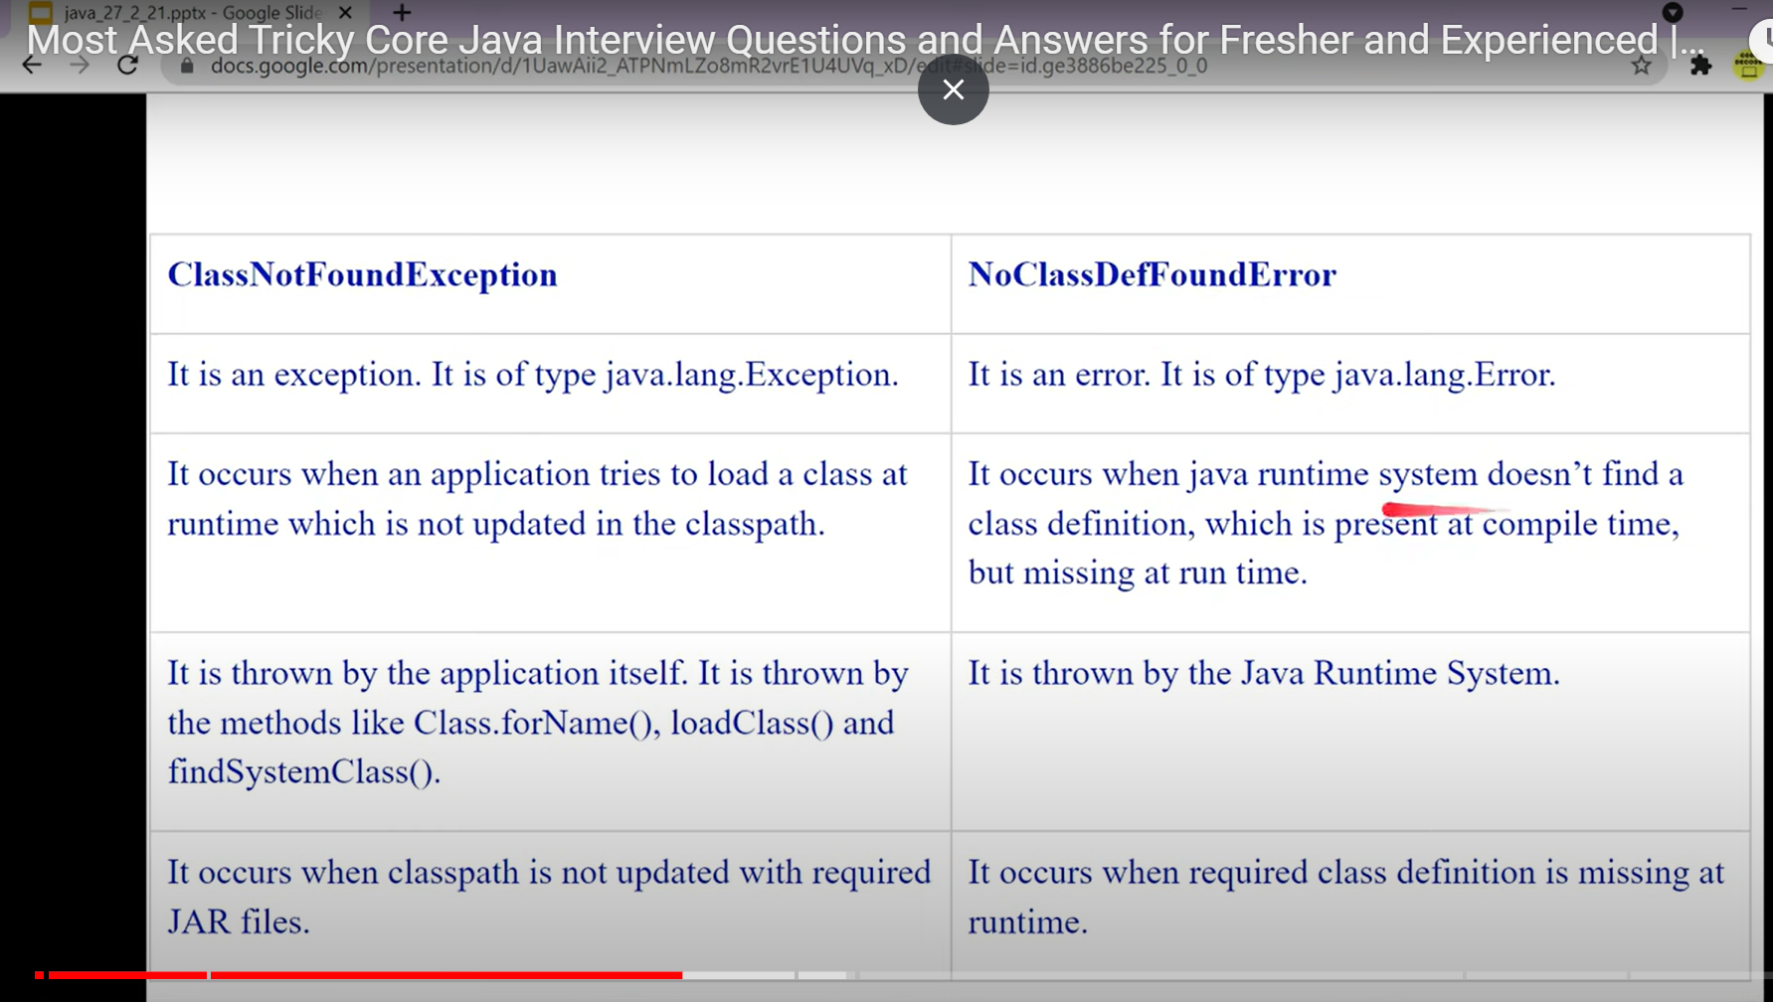

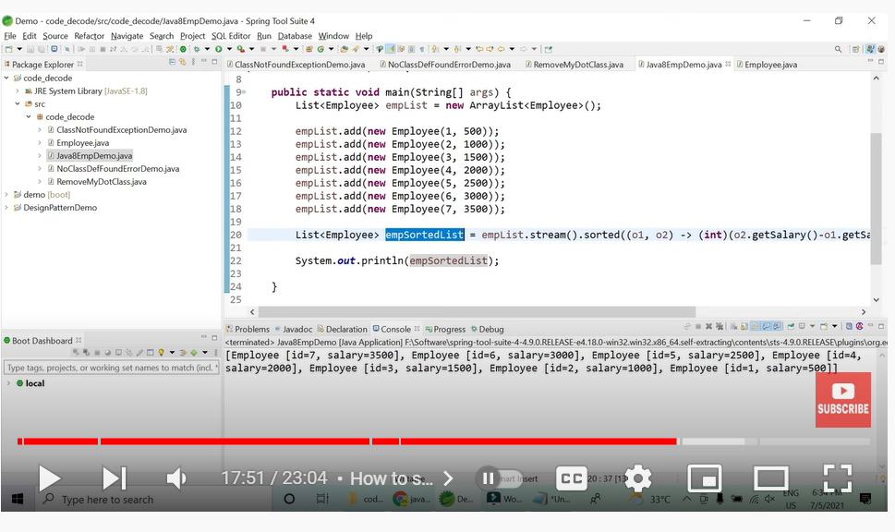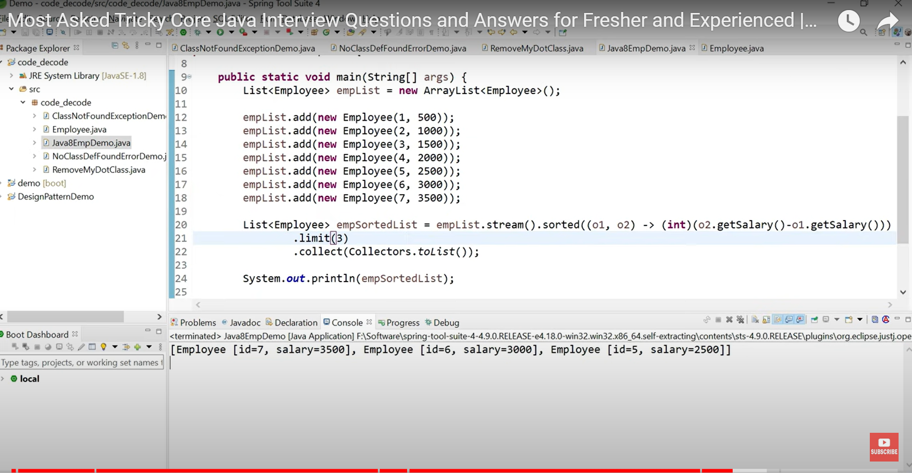

 Saga pattern in Microservices

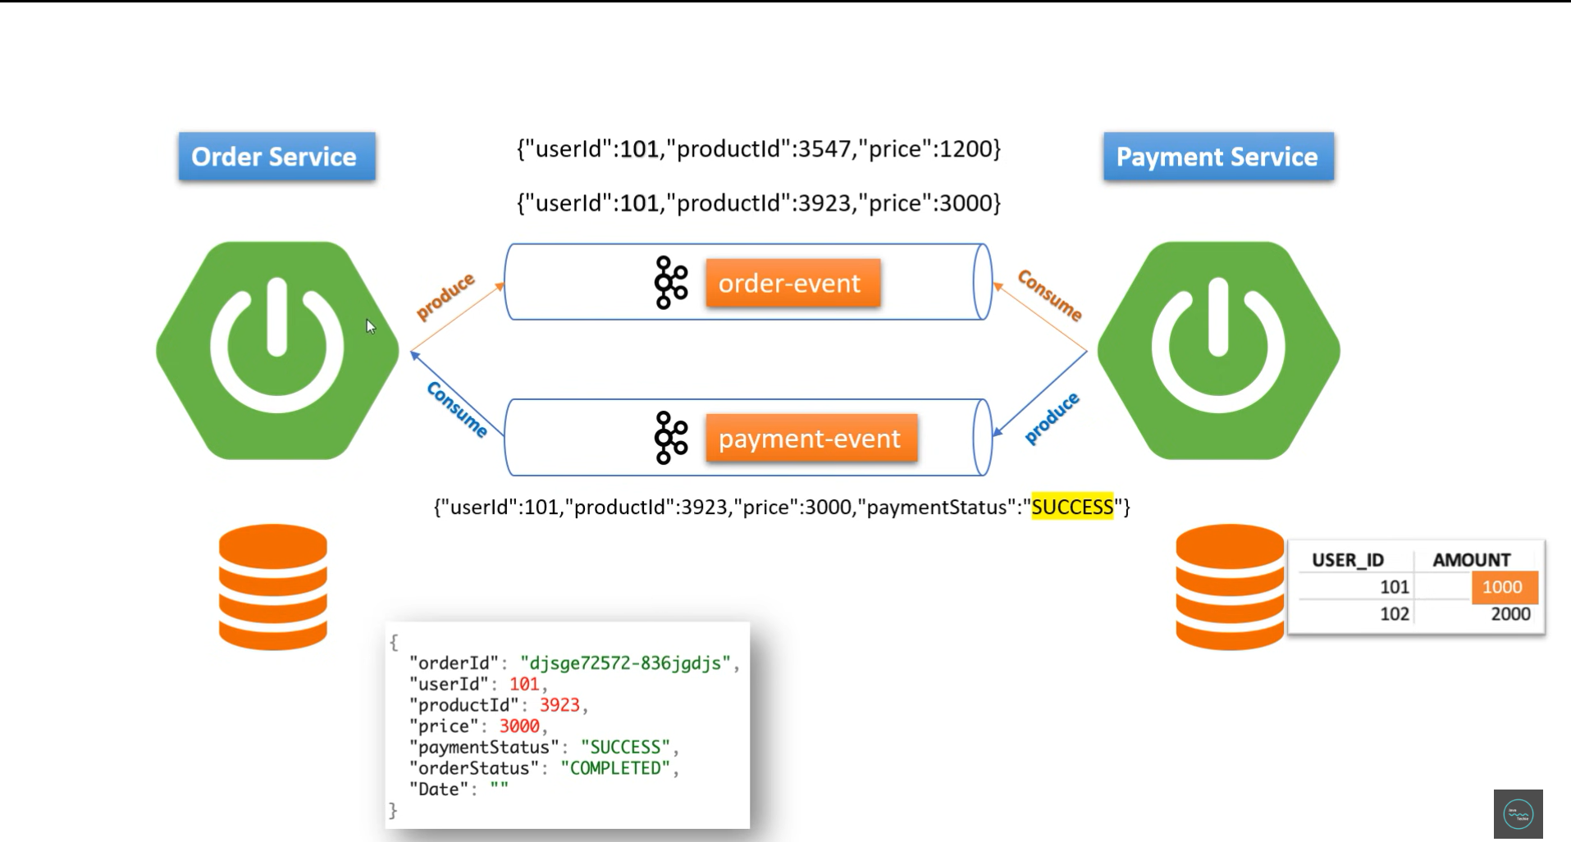

CQRS:

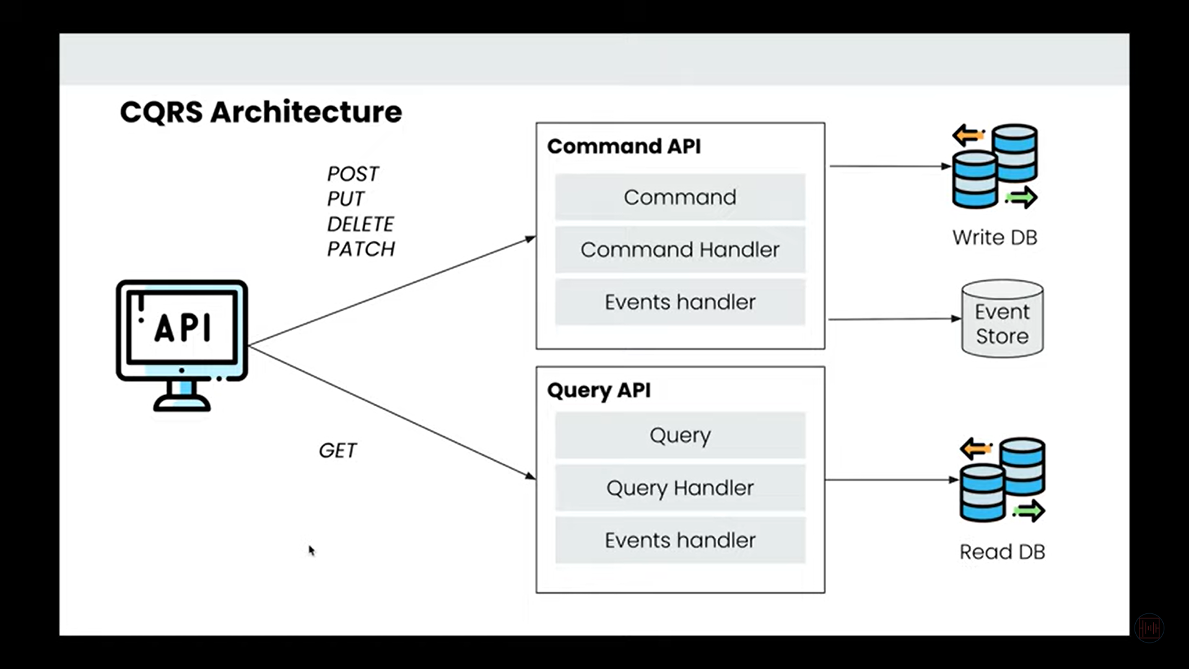

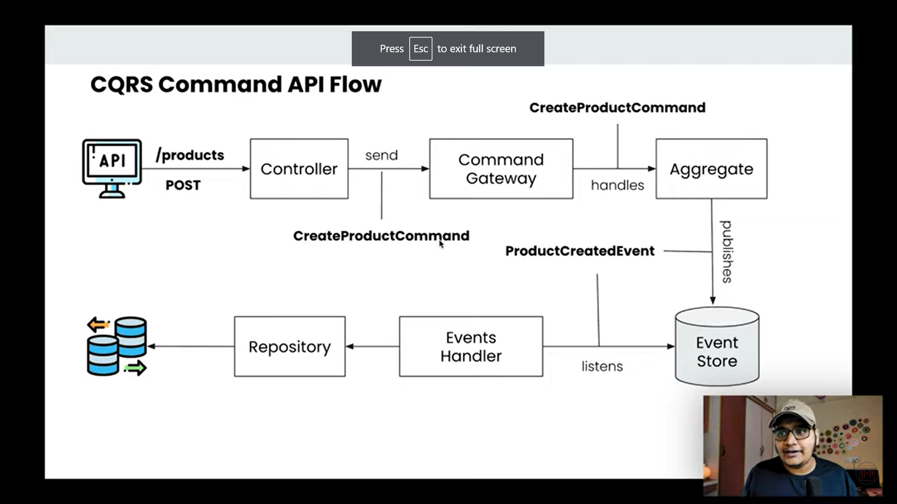

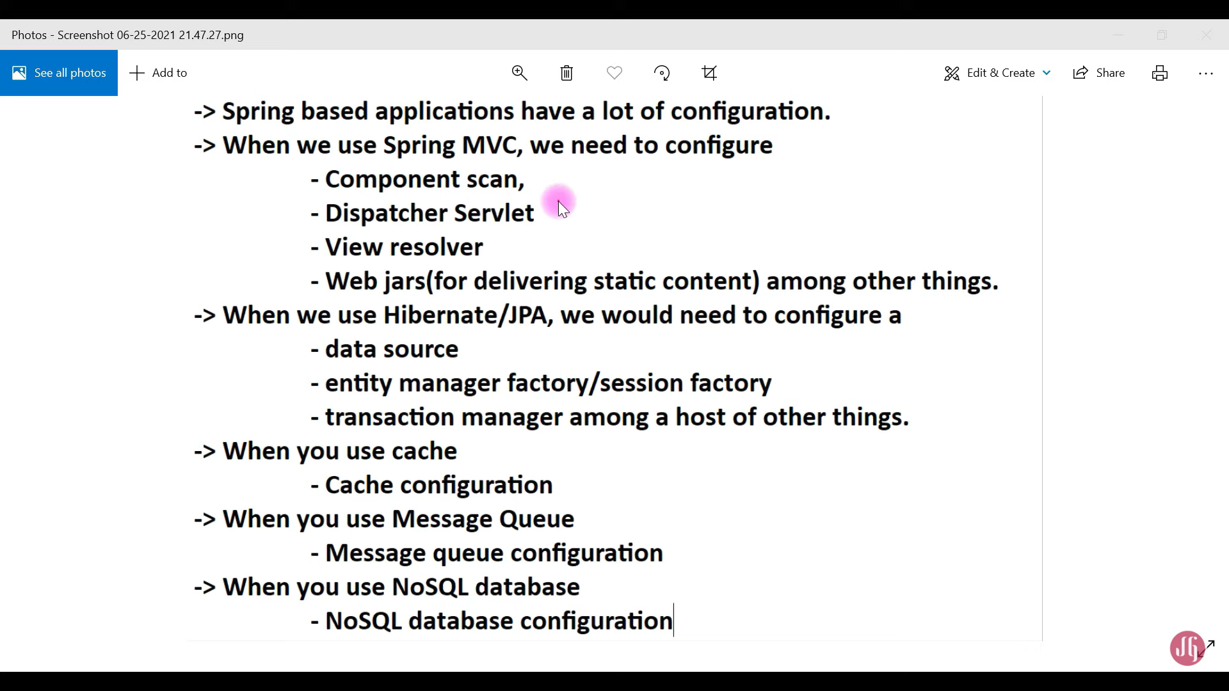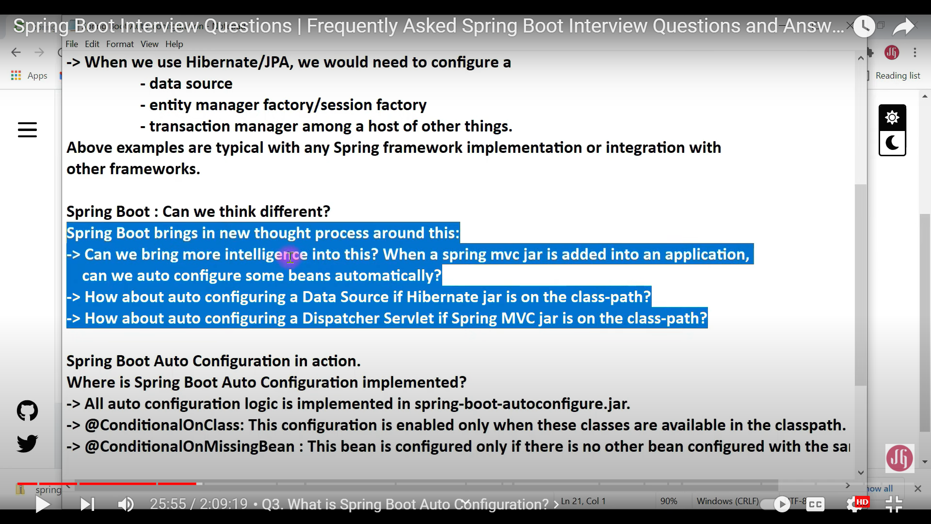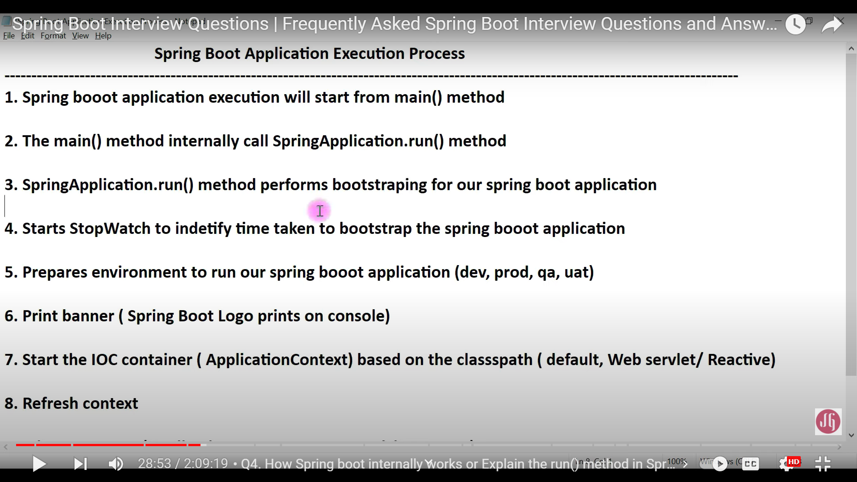

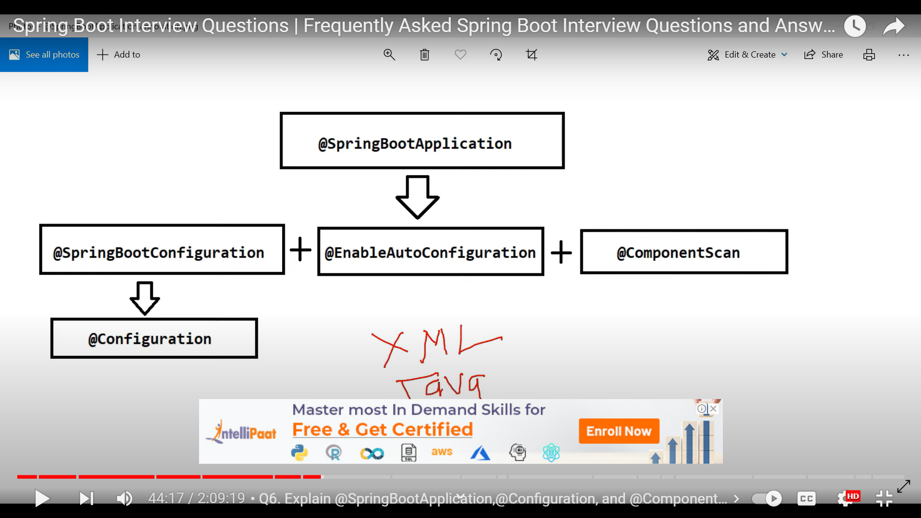

Starters:

* Maintain Compatible versions for all dependency.
* Group of dependency jars/transitive jars